Standard PPE Requirements For Department

Steel toe cap footwear is required for the department operation, whether these be in the form of boots or shoes, both are acceptable. Please contact you production manager immediately if you do not have the correct footwear. | 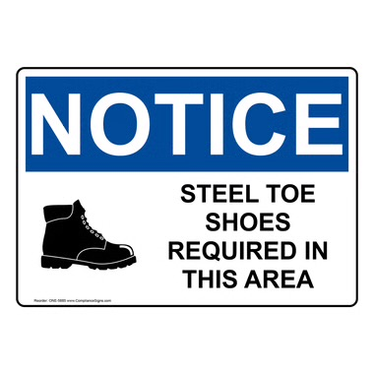
Ear protection is provided at the entrance to the department and is a requirement during production activity times. Please contact your production manager immediately if you require alternative hearing protection. | 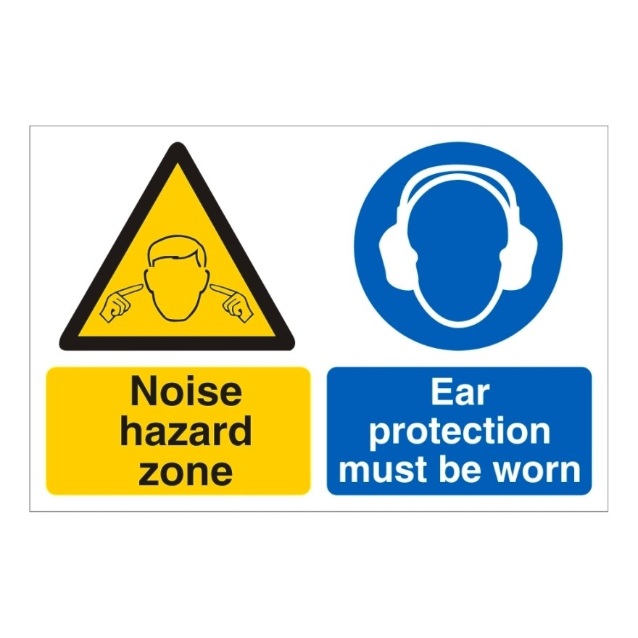

Key Purpose of The Procedure

The delivery part of RM7 is located to the far end of the machine and is where the finished books get piled into the required quantities (stacks). This area of the machine MUST NOT be accessed whilst the machine is running. If a safety guard opens whilst the machine is running, this must be immediately reported to the machine operator and the department manager. To be able to operate the delivery section of RM7 the following points MUST be followed,

- In the event of a pile up, only full trained and competent operators can intervene
- Only fully trained operators can control the delivery controls when clearing a pile up
- Entry to the delivery can only happen when the machine is stopped and the guard doors have been unlocked

Intervention Procedure

If an intervention is required at the delivery due to a pile up or any other issue with the machine, the following procedure MUST be followed by a trained operator,

- If the machine has not come to a stop already, the stop button on the exit of the delivery must be pressed in

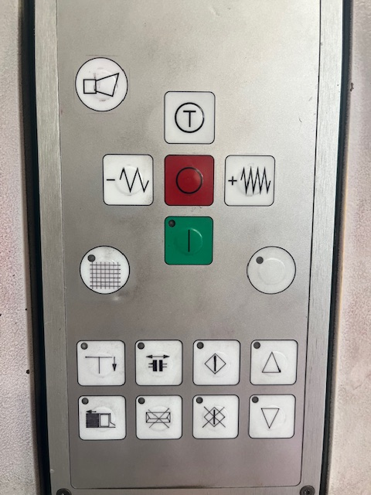

- Once the machine has stopped and the safety doors have disengaged, access can be made to the machine, press the release button to access the rear sliding door

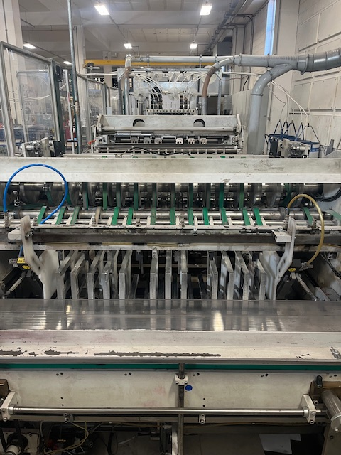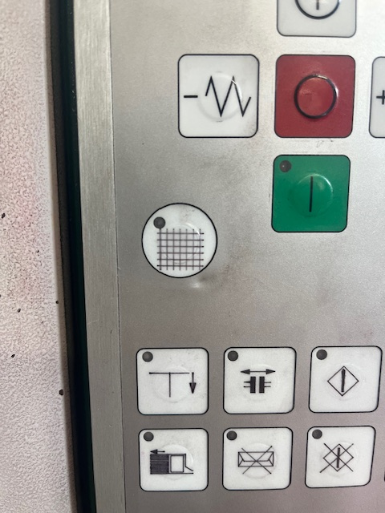

- If it is a pile up that requires clearing, lift the delivery into the ‘Up’ position and remove any obstructing books that may have caused or become damaged during the pile up.
- Once you are satisfied the blockage/pile up is clear, return the delivery to the ‘Down’ position and ensure that all staff has exited the machine before closing the interlocked doors
- Operator must then inch the machine to ensure books are freely move through the delivery as standard

